THOMAS MONROE BOOKS
Employee Training & SOP Tracker
The Restaurant Manager’s Toolkit, Book 1 - Sample Preview

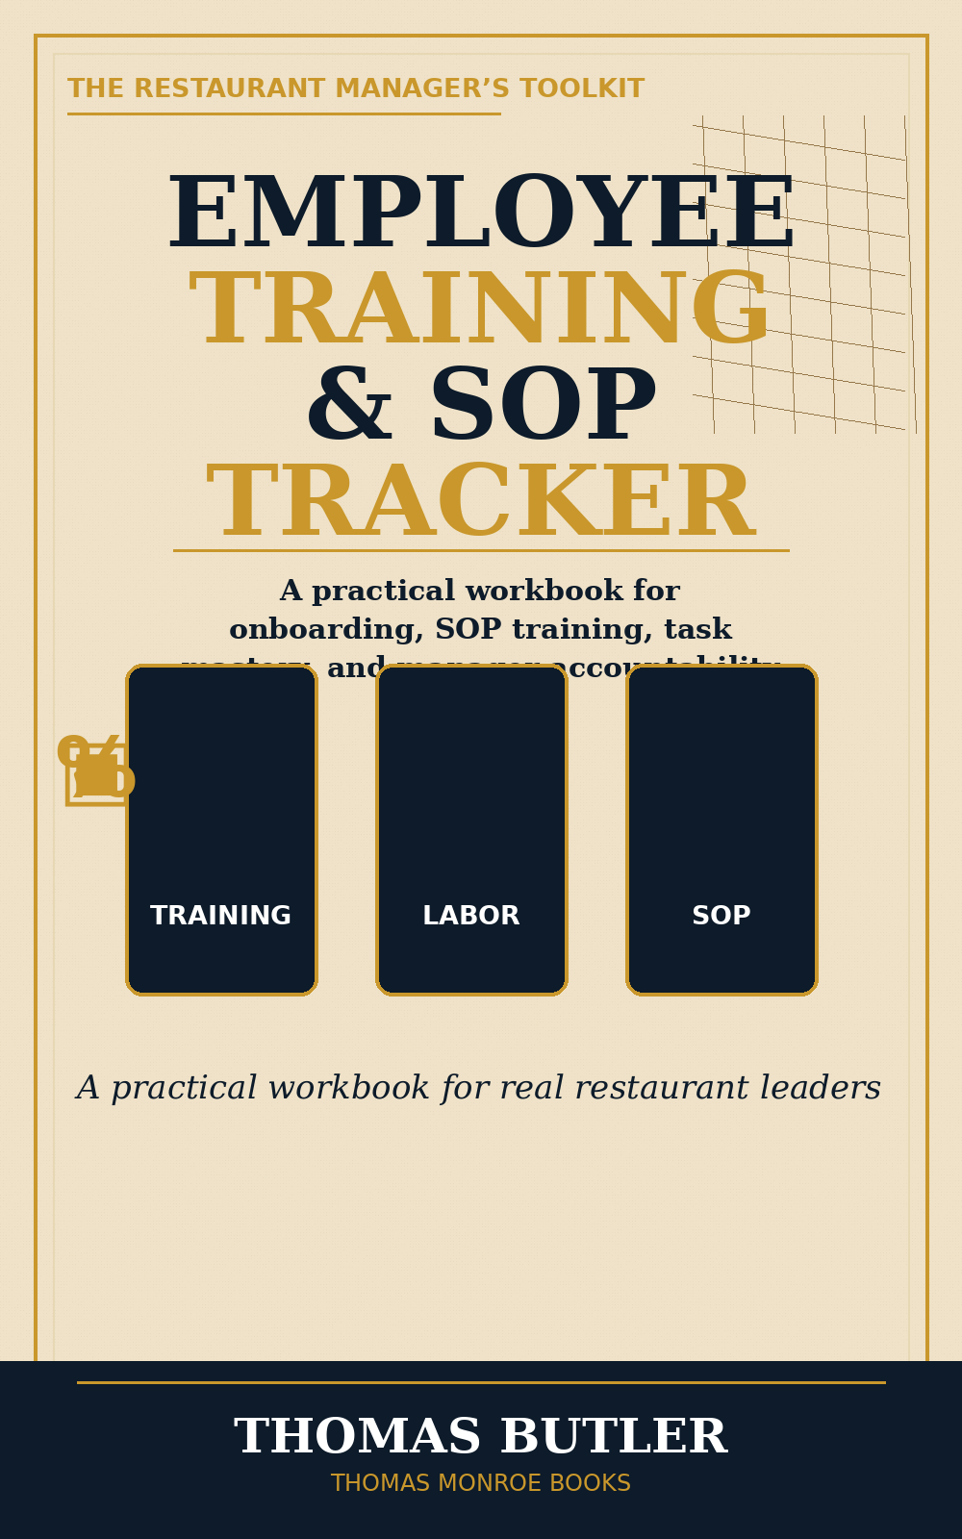

A practical workbook for onboarding, SOP training, task mastery, staff development, trainer sign-offs, and manager accountability.
This sample is a preview only. It is not the full book.

What this workbook helps a manager build
- A clearer onboarding path for new hires.
- Role-specific training trackers for FOH and BOH positions.
- Task mastery sheets so employees can be certified by skill, not by memory.
- Trainer sign-off pages so training is documented.
- Coaching and retraining logs for follow-up and accountability.
- 30/60/90-day review structure for early employee development.

New Hire Readiness Checklist
Item | Ready? | Manager Notes
Position and start date confirmed | [ ] Yes [ ] No
Uniform and appearance standards explained | [ ] Yes [ ] No
Required paperwork complete | [ ] Yes [ ] No
Training schedule assigned | [ ] Yes [ ] No
Trainer assigned | [ ] Yes [ ] No
First-day expectations explained | [ ] Yes [ ] No

Task Mastery Sign-Off
Task | Observed | Practiced | Certified
Opening station setup | [ ] | [ ] | [ ]
Guest greeting standard | [ ] | [ ] | [ ]
POS order entry | [ ] | [ ] | [ ]
Side-work completion | [ ] | [ ] | [ ]
Closing handoff | [ ] | [ ] | [ ]

A task should not be marked complete just because the employee heard it explained. It should be marked complete when the employee can perform the task correctly, consistently, and without being rescued.

