THOMAS MONROE BOOKS
Labor Control & Scheduling Planner
Book 2 Coming Soon - Sample Structure Preview

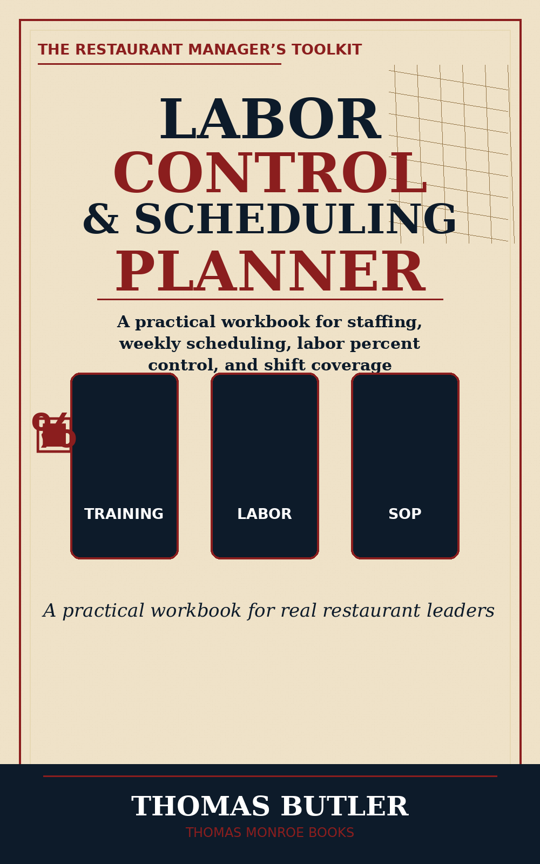

This is a coming-soon preview of the planned labor and scheduling workbook structure. Final pages and purchase links should be confirmed before public sale.
This sample is a preview only. It is not the full book.

What this workbook is planned to help a manager control
- Weekly scheduling discipline.
- Labor percent awareness.
- Shift coverage decisions.
- Call-out and overtime tracking.
- Sales forecast versus labor plan.
- Manager follow-up after labor misses.

Weekly Labor Planning Snapshot
Day | Projected Sales | Scheduled Labor | Target Labor % | Manager Notes
Monday | $______ | $______ | ____%
Tuesday | $______ | $______ | ____%
Wednesday | $______ | $______ | ____%
Thursday | $______ | $______ | ____%
Friday | $______ | $______ | ____%

Shift Coverage Review
- Was every station covered by skill, not just body count?
- Did the schedule match the expected sales pattern?
- Were strong employees placed where the shift needed protection?
- Did managers review call-outs and late changes?
- What adjustment should be made next week?

