THOMAS MONROE BOOKS
The Owner's Chair
The Hidden Cost of Unclear Restaurant Leadership - Sample Preview

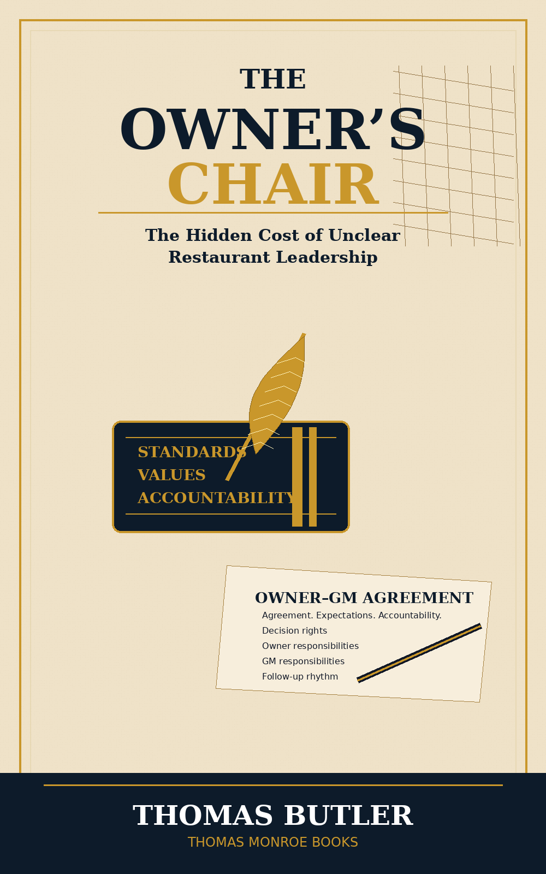

A serious restaurant leadership book for owners, GMs, operating partners, and managers who want clearer authority, stronger standards, and a restaurant that runs on truth instead of personality.
This sample is a preview only. It is not the full book.

Why this book exists
Some owners do not face the truth because they hired someone they wanted to trust, and admitting that person cannot lead would mean admitting the business is exposed. Some do not face it because survival can be mistaken for health. But whether the truth is avoided intentionally or missed honestly, the restaurant still pays.
- It pays in labor.
- It pays in food cost.
- It pays in training failure.
- It pays in turnover.
- It pays in managers who burn out.
- It pays in owners who feel trapped inside the very business they built.
The Owner's Chair is not just a position of power. It is a position of responsibility. The chair has weight: financial, emotional, operational, cultural, and personal.

Owner-GM Agreement Preview
A restaurant should not run on assumptions between the owner and general manager. The Owner-GM Agreement gives both roles clarity before confusion becomes expensive.
Agreement Area | Questions to Clarify
Decision rights | Which decisions belong to the GM? Which require owner approval?
Non-negotiable standards | Which standards cannot be changed without owner agreement?
Reporting rhythm | What numbers, reports, and follow-up meetings must happen every week?
Owner involvement | When should the owner step in, and when should the owner stay out?
Accountability | How will missed expectations be corrected without drama?

Leadership Bench Builder Preview
A restaurant should not wait until it needs a leader to begin teaching people how to lead. Leadership should be built before the restaurant is desperate.
- Identify three to five people with leadership potential.
- Give each person one responsibility beyond the normal job.
- Test how they respond to correction, pressure, and communication.
- Promote with evidence, not hope.
- Build leaders early. Test responsibility slowly.

