THOMAS MONROE BOOKS
Quiet Gravity
Leadership Mindset Reading - Sample Preview

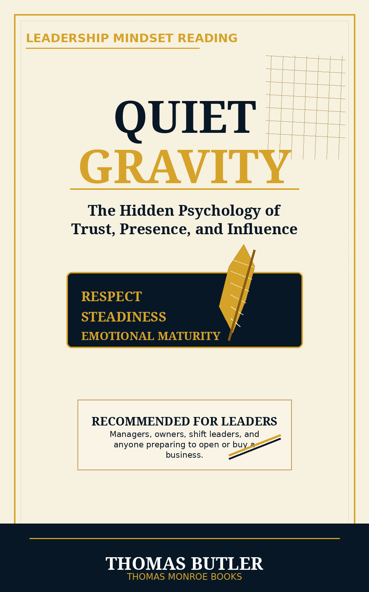

A book about respect, self-awareness, emotional responsibility, steadiness, trust, and how people remember the way they felt around you.
This sample is a preview only. It is not the full book.

Recommended leadership use
Quiet Gravity is recommended first-month reading for restaurant owners, general managers, assistant managers, shift leaders, trainers, and anyone preparing to open, buy, or lead a business.
It belongs before authority hardens into habit. The purpose is to help leaders begin with respect, presence, steadiness, and emotional responsibility before they are trusted with teams, correction, pressure, and accountability.

Quiet Gravity in full
Quiet Gravity was never about becoming louder. Never about controlling every room. Never about rehearsed confidence. Never about social tricks. Never about dominating attention.
It was always about becoming stronger in the ways people feel before they describe: attention that makes people feel received, ease that lowers pressure, timing that protects trust, restraint that shows confidence, warmth without need, strength without crowding, leadership without domination, honesty without unnecessary harm, and consistency under pressure.
A presence that makes life feel steadier, lighter, clearer, safer, and stronger.

Why managers should read it
Manager Role | Why this matters
GM | Sets the emotional standard for the whole operation.
Assistant Manager | Learns how to carry authority without making people smaller.
Shift Leader | Handles pressure, correction, and conflict with steadiness.
Trainer | Shows new employees what respect looks like in action.
Business Starter | Begins with the right mindset before building systems around people.

