THOMAS MONROE BOOKS
Restaurant SOP & Station Operations Builder
The Restaurant Manager’s Toolkit, Book 3 - Sample Preview

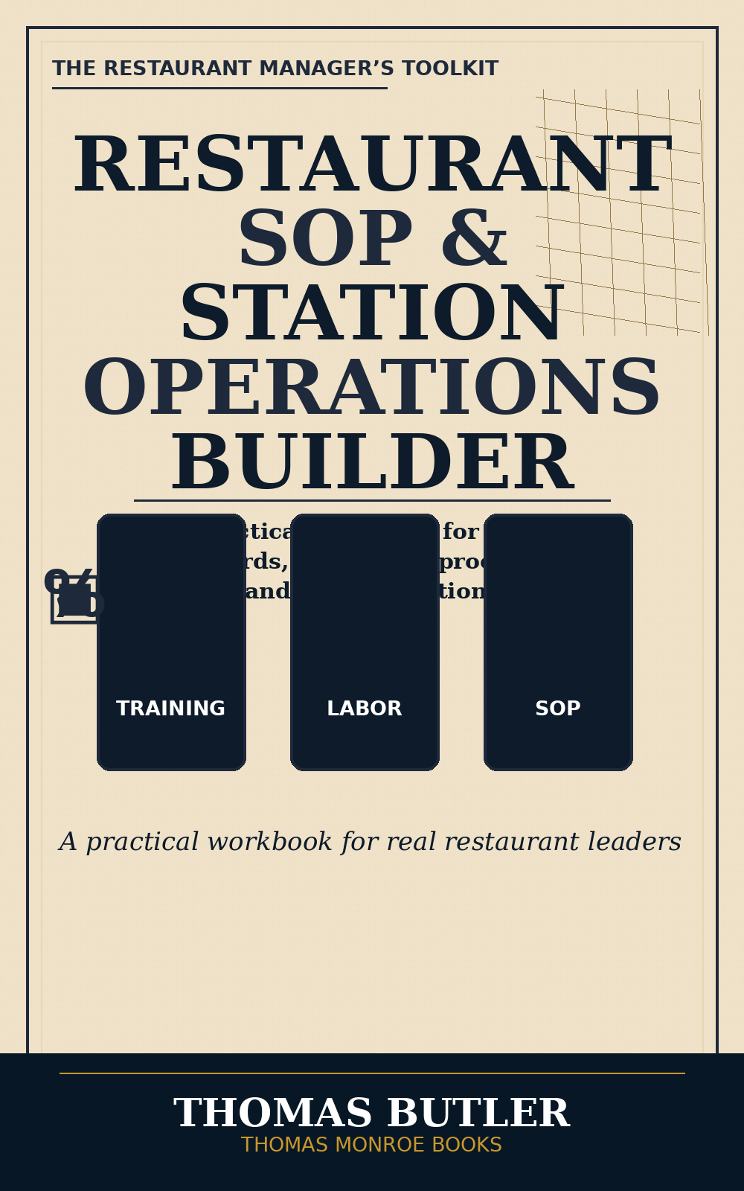

A practical workbook for building restaurant SOPs, station standards, checklists, procedures, and daily operating systems.
This sample is a preview only. It is not the full book.

What this workbook helps a manager build
- Clear SOPs for repeated restaurant tasks.
- Station standards that trainers and managers can inspect.
- Opening and closing checklists.
- Food prep, cleaning, safety, and service procedure templates.
- Manager verification pages so standards are not only written but followed.

SOP Template - Position Task
SOP Field | Manager Entry
Task Name
Position Responsible
When This Task Happens
Tools / Supplies Needed
Step-by-Step Procedure | 1.  2.  3.
Common Mistakes to Avoid
Manager Verification Standard

Station Opening Checklist
Station Standard | Done | Manager Initials
Station cleaned and sanitized | [ ]
Required tools in place | [ ]
Par levels checked | [ ]
Labels and dates verified | [ ]
Waste or shortages reported | [ ]

